**Week 8 Lab Assembler**

**Group 65**

**Integrants: 110504517 李睿穎 (Leader)，110504518 鍾秉均 (Member)**

**Full Code**

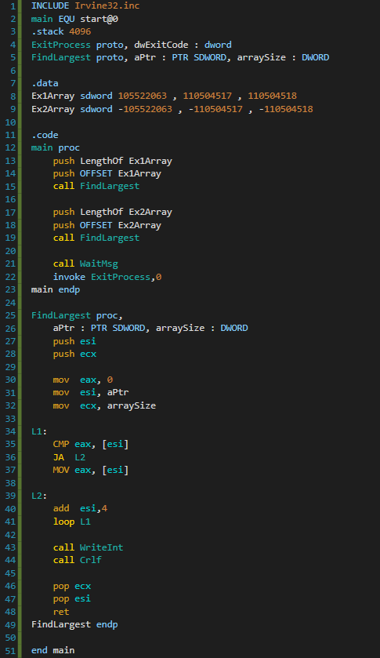

**Explanation**

Main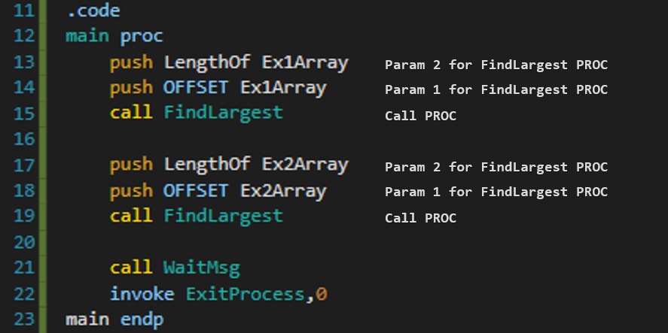

FindLargest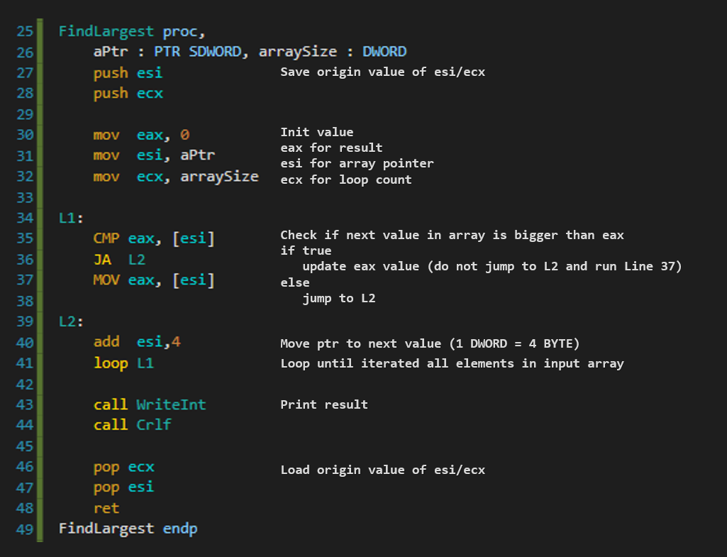

**Print Result**

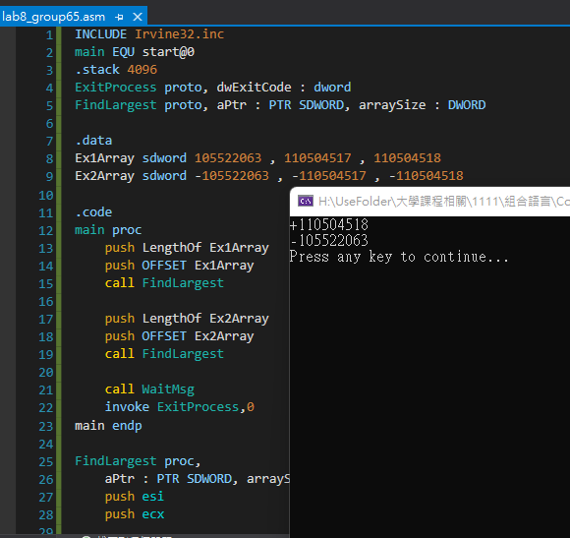

**Reflection**

For this week’s lab we learnt how to used the PROTO operator and how to go through an array, we had some complications with pop and push operations because order is crucial when using those operators. We also learnt how to pass parameters to a PROC function.